Science 9 Course Outline 2021 Byrne Creek Secondary
Ms. Wilson: tammy.wilson@burnabyschools.ca
Website: https://www.wilsonswebpage.com
Room:
Textbook: Science Probe 9

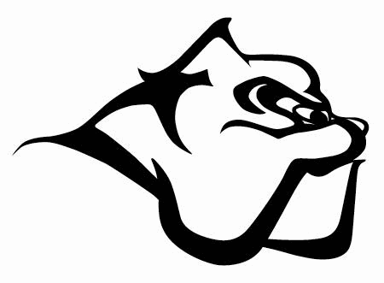

The aim of this course is to develop your scientific inquiry skills and develop the following competencies
SKILLS YOU WILL BE DEVELOPING:
- Questioning and predicting
- Planning and conducting
- Processing and analyzing data and information
- Evaluating
- Applying and innovating
- Communicating
TOPICS WE WILL BE EXPLORING:
- Chemistry: BIG IDEA – The electron arrangement of atoms impacts their chemical nature.
- Biology: BIG IDEA – Cells are derived from cells.
- Physics: BIG IDEA – Electric current is the flow of electric charge.
- Ecology: BIG IDEA – The biosphere, geosphere, hydrosphere, and atmosphere are interconnected, as matter cycles and energy flows through them.

HOW YOU WILL BE ASSESSED:
Emerging (EMG) | Developing (DEV) | Proficient (PRO) | Extending (EXT)
With support, I can understand the basic ideas of this course. | I can understand the basic ideas of this course and have some basic skills | I fully understand the bid ideas of this course and can explain concepts and problem-solve with ideas. | My work is exceptional and detailed. I can demonstrate high level of critical thinking and analysis, and make meaningful connections between ideas.

MARKS BREAKDOWN:
Tests and Quizzes | 65%
Projects | 15%
Assignments (labs and homework) | 10%
CLASSROOM EXPECTATIONS:

- SOCIAL RESPONSIBILITY:
- Treat others and your environment with kindness, dignity and consideration. Be kind. Be helpful. Be safe.

- PERSONAL RESPONSIBILITY:
- Be present: Attend class, be on time, ready to learn, with all necessary materials, engage in the lessons.

- Follow all safety procedures.

- Be responsible for your learning: Stay on top of your work, recognize when you need to ask for help, and do your best.

- Absences must be excused by a parent/guardian who calls the office before school starts on the day you are absent. If you miss a class, students are responsible to find out what was missed and get caught up in a timely fashion by checking the schedule at http://www.wilsonswebpage.com.

- Cell phones: Cell phones are not permitted during instructional time and are expected to be left in your backpack and turned off during class time. Students caught using a device during instruction may have it removed from their person and placed on the white board ledge until the end of class. Students may use cell phones to listen to music during independent work time only after asking for teacher permission

