Static Electricity At Home Activity
Introduction: All matter is made up of atoms. Atoms are made up of protons (positive), neutrons (neutral), and electrons (negative).
Would the following subatomic particles attract each other or repel one another?
Two protons _____________
Two electrons ____________
A proton and an electron _________
Question: What makes objects attract or repel each other?
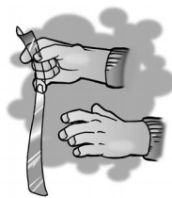
Materials: Plastic grocery bag, Scissors
Part 1: Charged plastic and charged skin
1. Cut 2 strips from a plastic grocery bag so that each is about 2–4 cm wide and about 20 cm long.
2. Hold the plastic strip firmly at one end. Then grasp the plastic strip between the thumb and fingers of your other hand as shown.
3. Quickly pull your top hand up so that the plastic strip runs through your fingers. Do this three or four times.
4. Allow the strip to hang down. Then bring your other hand near it.
5. Write “attract” or “repel” in the chart to describe what happened.

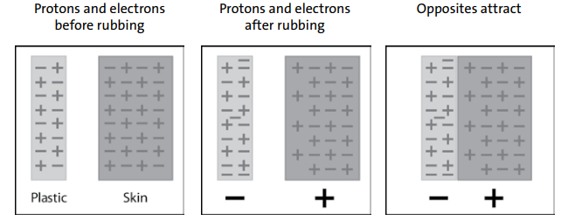

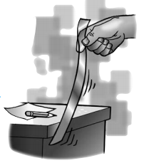
Part 2: Charged plastic and neutral desk
1. Charge one strip of plastic the same way you did previously.
2. This time, bring the plastic strip toward your desk or chair.
3. Write “attract” or “repel” in the chart on the next page

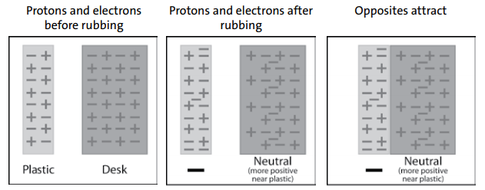
Part 3: Two Pieces of Charged Plastic
1. Charge two strips of plastic
2. Slowly bring the two strips of plastic near each other.
3. Write “attract” or “repel” in the chart on the next page

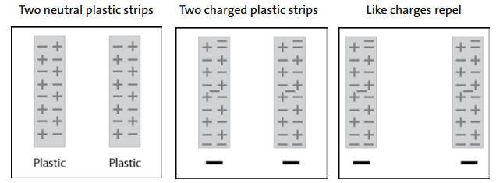
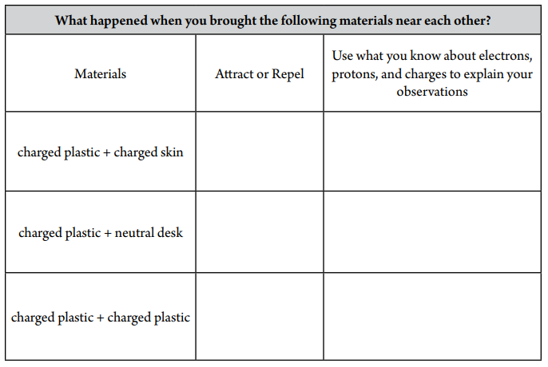
TAKE IT FURTHER
Materials: Inflated balloon, Small pieces of paper, confetti-size
Procedure:
- Rub a balloon on your hair or clothes.
- Bring the balloon slowly toward small pieces of paper
Write captions beneath each picture explaining what happened between the balloon and your hair and the balloon and the paper in the activity.
