Bio 11 Cell Reading Check Questions
Read pages 87 - 98
- List the three main points of cell theory.

- What is the size range of the very smallest cell to the very largest single cell?

- What are the functions of the three basic structures of most cells?

- How do prokaryotes differ from eukaryotes? Do prokaryotes have cell membranes?

- What is the function of proteins in the cell membrane?

- What is the function of the carbohydrate’s association with the cell membrane?

- What is the function of the cell wall? Name two kinds of cells that have cell walls.

- How are the nuclear envelope, nucleolus, and chromosomes related to one another? Briefly describe each ofthese structures.

Label the parts of the cell:
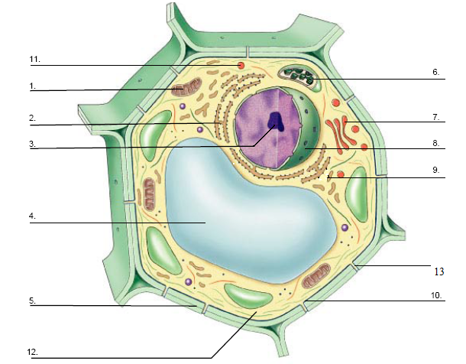

Structure | Function
Nucleus
Nucleolus
Nuclear Pores
Cytoplasm
Mitochondria
Chloroplast
Ribosomes
Smooth ER
Rough ER
Golgi Apparatus
Lysosomes
Vacuoles
Plastids
cytoskeleton

