Graphing Notes (Keep this handy) Name: ______________

Importance of Line graphs
- showing specific values of data. If one variable is known, the other can be determined.
- showing trends and relationships in data clearly.
- they visibly depict how one variable is affected by the other as it increases or decreases.
- allowing the viewer to make predictions within recorded data, called interpolation,
- make predictions about data not yet recorded (outside of plotted data), called extrapolation.

Interpolation vs. Extrapolation
- Interpolation is finding data plotted within the graph.
- Extrapolation is predicting data outside of plotted graph

Discrete vs Continuous Data
- Join the dots when data is continuous. DO NOT join plots when data is discrete:

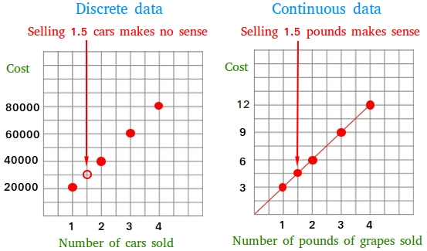

Best Fit Line
- Line Drawn that REPRESENTS the data but does not connect to every point.
- Should be equal number of dots above the line as below.
- Does not have to meet with origin.

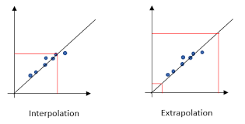
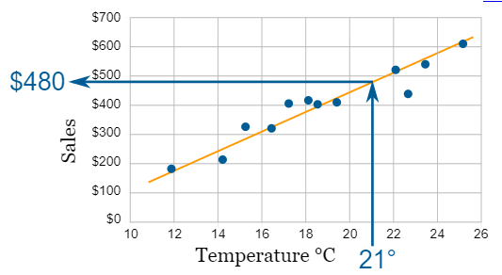

Graphing Relationships:
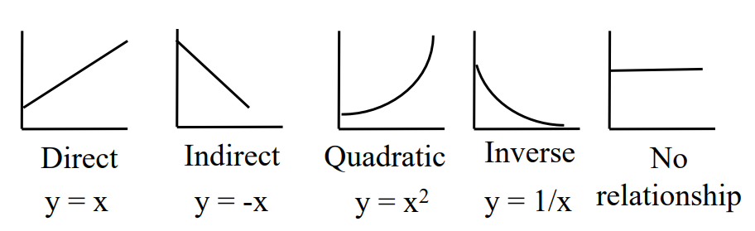

Variables
- Independent (manipulated) variable goes on x-axis. Often time is on the x-axis.
- Dependent (Responding) variable on y-axis.
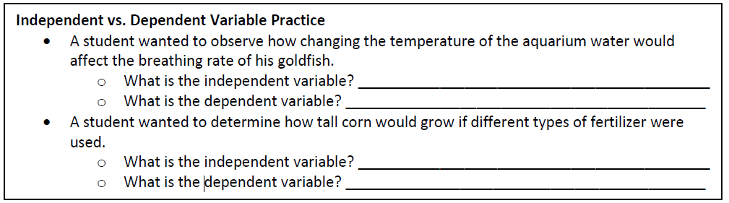

Graphing Commandments
- Use PENCIL
- Make it BIG. At least half a page.
- Label Axis with UNITS.
- CONSISTENT Scale.
- Scale on one axis can be different than other axis.
- Scale does not need to start at zero.
- Only plot data given (don’t join to origin if you don’t have that data).
- Join dots only if data is continuous.
- Make LEGEND if plotting more than one data set on same graph. Use different colours or symbols.
- Descriptive title (not time vs temperature)

Graphing Practice – Hand in Name: _________________
The thickness of the annual rings indicates what type of environmental situation was occurring the
time of the tree’s development. A thin ring usually indicates a rough period of development such as lack
of water, forest fires, or insect infestation. On the other hand, a thick ring means a prosperous period of
development. Use the information from the data table below to create a proper scientific graph and to
answer the corresponding questions.
Age of Trees (in years) | Average Thickness of Annual Rings in Forest A (millimeters) | Average Thickness of Annual Rings in Forest B (millimeters)
10 | 20 | 24
20 | 24 | 28
30 | 30 | 35
35 | 34 | 38
40 | 36 | 41
50 | 37 | 46
60 | 46 | 55

1. What is the dependent variable? ____________________
2. What is the independent variable? ___________________
Plot these data on the graph on the next page. Then answer the following questions.
3. What was the average thickness of annual rings for 45 year old trees in Forest A? ______

4. What is it called when you make predictions within given data, such as made in question #3? ______________________

5. Extrapolate what you think the average ring thickness would be of Forest B at 70 years. ____
6. Explain what you think happened to Forest A in the years between 30-50. __________________________________________________________________ ____________________________________________________________________
7. Based on the data shown, what can be concluded about the comparative health of
Forest A & B? _________________________________________________________
8. Is your graph a perfectly straight line? Offer some explanation as to why this is. ____________________________________________________________________ ____________________________________________________________________
9. What type of relationship (constant, direct, or indirect) exists between the age of trees and
the average thickness of the tree’s rings? Explain. _______________________________________________________________________ _______________________________________________________________________

Title: ________________________________________________________________

Graph Checklist. Did you....
- Use pencil?
- Give your graph a descriptive title?
- Label both axis with units?
- Create a legend?
- Answer questions?

