Metric System
Base Units
Measurement | Base Unit | Symbol
Length
Mass
Volume
Time
Temperature

Note: One cubic centimeter = 1 mL

Prefixes:
Prefix | Symbol | Meaning | Order of Magnitude
Giga- | G | 1 000 000 000 | 10⁹
Mega - | M | 1 000 000 | 10⁶
 | k |  | 10³
hetco - | h
deka- | da |  | 10¹
 | base unit | 1 | 10⁰
deci- | d
centi- | c
milli - |  | 0.001 | 10⁻³
micro -
nano - |  |  | 10⁻⁶
pico - |  | 0.000 000 001 | 10⁻⁹

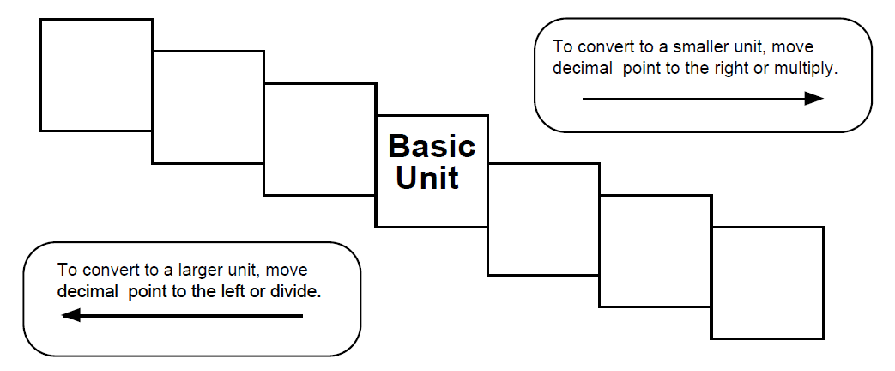

Convert the following:
1000 mg = ____________ g 1 L = _________________ mL
160 cm = _____________ mm 14 km = ______________ m
100 g = ______________ kg 250 m = ______________ km
75 km = _____________ cm 2 kg = ________________ mg
2.4 mm = _____________ um 18 um = ______________ mm
4.3 cm³ = _____________ mL

Which metric unit would you use to measure each of the following?
- Volume of a glass of milk ______________________
- Length of your textbook ______________________
- Mass of a mouse ______________________
- Mass of a killer whale ______________________
- Volume of a marble ______________________
- Temperature of the Gulf of Mexico ______________________

Read pages 11-15. Answer Practice Problems 1-5 on page 15.

