PREDICTING AND MEASURING CURRENT
Purpose: Setting up electrical circuits. Predicting and measuring current.
Materials: 2 cells and holders, alligator clips, 2 bulbs, switch.
- Using just 2 cells, wires, 1 light bulb, and switch, connect everything to make the light bulb light up. When it works, draw a circuit diagram of your set up below:
Draw an arrow to show the direction the electrons are flowing.

- What happens to bulb brightness when you add another bulb in series (3 in total) ? __________
- What happens to bulb brightness when you add another cell (3 bulb, 3 cells in total)? ______________
- Connect the ammeter (in series) between the cells and the bulbs in such a way that the electrons are flowing from the cells, through the ammeter, then to the bulbs. Record the current: ________________mA. This is the current BEFORE the bulbs.
- PREDICT: do you think the current will be the same/less/more after the first bulb but before the second bulb? ___________.
- Disconnect the ammeter and place it AFTER first the bulb but BEFORE second bulb. Record the current: ________mA.
- Reconnect the ammeter to be after all three bulbs. Record: _______mA.
- Remove the ammeter, keeping everything else connected.
- PREDICT what will happen to the other two bulbs when the middle bulb is unscrewed. _____________________________________________ ______________________________________________________
What is your reasoning? ____________________________________ ______________________________________________________
Go ahead and unscrew the middle bulb, keeping remainder of circuit intact. What happened? _________________________________________ Try unscrewing a different bulb instead. What happens to the other two bulbs when one of them is unscrewed? _______________________________ because _________________________________________________

SUMMARIZE:
When in SERIES, what happens to bulb brightness when more are added? _________________________________________________
When in SERIES, what happens to the other two bulbs if one breaks/goes out/is disconnected? ___________________________
When in SERIES, how does the current entering the light bulb compare with current leaving the bulb? _________________________________.Draw a conclusion about what happens to electrons when entering and leaving the bulb. ________ ___________________________________________________

CHALLENGE: How can you make the other bulbs stay lit when one of them is connected but unscrewed? Draw your circuit diagram below:
CURRENT IN PARALLEL CIRCUITS
- Build a circuit (2 cells, 3 bulbs) without any ammeters to look like the diagram on the right.
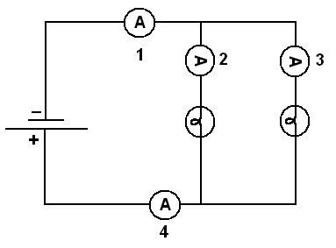
- Are the bulbs same/brighter/dimmer compared to when they were in series? ________________
- Measure the current with an ammeter at position #1: _____________
- Measure the current with an ammeter at position #2: _____________
- Measure the current with an ammeter at position #3: _____________
- Measure the current with an ammeter at position #4: _____________
- Compare current at Position #1 (total current before branches) to position #4 (total current after branches) ______________________________
- Compare current at position 2 to position 3 ________________________
- Compare currents of positions 2 or 3 to Total Current (#1). Are they the same, more, less? __________________________________________
- PREDICT what you think would be the current entering a 3rd bulb in parallel.

SUMMARIZE: What general rule can you apply to current at each bulb when they are added in parallel?
____________________________________________________________________________________________________________________________
If wires are difficult, you can try this PHET simulation to build your own circuits:
https://phet.colorado.edu/sims/html/circuit-construction-kit-dc/latest/circuit-construction-kit-dc_all.html

