LS11  **PASSIVE TRANSPORT WORKSHEET**

Vocabulary 5-4: Movement of Materials Through the Cell Membrane

Text reference pages 100-102

1. Be able to define the following in your own words: Homeostasis (p31), Diffusion, Osmosis, Concentration Gradient, Equilibrium, Selectively permeable, hypotonic, isotonic, hypertonic.
2. How is osmosis involved in homeostasis?
3. Compare and contrast osmosis and diffusion.
4. Observe the cell in the container below to complete the chart on the right.

[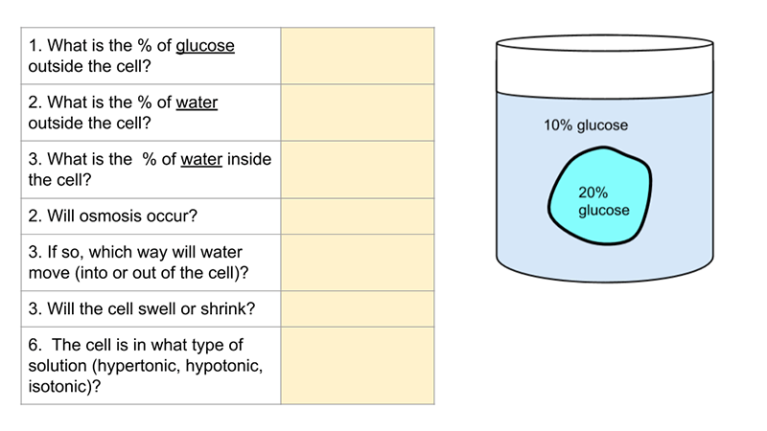](https://docs.google.com/presentation/d/1lCOccZiO5ckp8rxrPXBYdOJRI-wnCJO_WPslYWdz9Go/edit?usp=sharing)

[](https://docs.google.com/presentation/d/1lCOccZiO5ckp8rxrPXBYdOJRI-wnCJO_WPslYWdz9Go/edit?usp=sharing)

1. Observe the experiment with a glass U-tube below. Assume glucose can pass through membrane
2. Compare side A to side B in terms of tonicity:
3. Which way will the following move? Choose either ( A🡪B, or B🡪A, or neither)

Water _______________ Glucose______________

1. Will the concentration of glucose of side B increase or decrease as the experiment runs?
2. 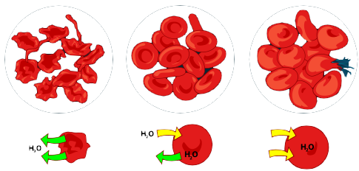Label the three images as either isotonic, hypertonic, or hypotonic solutions.

**Transport Worksheet** Chapter 5-4 (read pages 99-104)

1. Be able to define the following: endocytosis, phagocytosis, pinocytosis, exocytosis. Compare and contrast Passive Transport to Active Transport. Name some types of each.
2. What two things are needed for facilitated diffusion to occur?
3. Why would a cell pump certain ions against a gradient? What ions are moved across a membrane by pumps?

Fill in the blank. Not all choices will be used: Osmosis, diffusion, endocytosis, exocytosis, equilibrium, high, low, equal, Selectively permeable, impermeable, Active, passive, facilitated, energy, phospholipid, bilayer, proteins, molecules, solute, solvent, solution, hypotonic, isotonic, hypertonic, solute, solvent, solution.

Movement across the cell membrane that does not require energy is called ________________transport.  
The cell membrane is composed of proteins embedded in a ___________________ bilayer. The cell membrane is _______________________________ because it lets only some particles through. If there is a concentration gradient, substances will move from an area of high concentration to an area of _________________concentration in passive transport. _______________________is the simplest type of passive transport. The diffusion of water through a selectively permeable membrane is called _____________________. The direction of water movement across the cell membrane depends on the concentration of free water _____________________________. A solution that causes a cell to swell is called a ___________________________solution. The process of taking material into the cell by infolding of the cell membrane is called ________________________. In ________________________, membrane proteins help molecules across the membrane. Facilitated diffusion moves substances down their concentration gradient using _________________. In salt water, the salt is the ____________________ and the water is the ___________________.

1. Going further: Check out this osmosis simulation (Grade 12):

<http://video.esc4.net/video/assets/Science/Biology/Gateway%20Resources/cell%20homeostasis%20virtual%20lab%20-%20activity/index.html>