Bohr Model Worksheet Name: _________________
- The first shell can hold ______ electrons. The 2nd shell holds: _________. 3rd Shell: ________

- What is a valence electron? _________________________________________________________

- Identify the elements for the Bohr model diagrams are shown below.
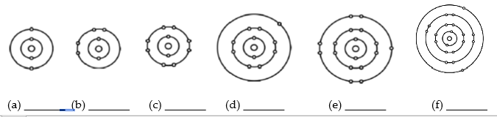

- Practice drawing the Bohr Model for the following elements:
Lithium Sodium Potassium

- What do you notice about the number of VALENCE electrons in the above Bohr Models?
- Which GROUP number (column) do the above elements belong to? ____________________
- Draw Bohr models for Beryllium, Magnesium, and Calcium:

- What GROUP number (column) are these elements in? _________What do you notice about the number of valence electrons?

- PREDICT the number of VALENCE ELECTRONS for strontium. _________

- Draw Bohr Models for Helium, Neon and Argon:

- What can you say about their valence SHELLS?

- Draw Bohr Models of Boron, Carbon, Nitrogen:

- Compare these with the previous sets of Bohr Models you drew. What do you notice about the number of valence electrons as you move from Left to Right along a period (row) of the periodic table?

- Predict the number of valence electrons for each element based on its location in the periodic table.
Barium ________ Lead ________ Bismuth _______ Cesium _________
- Compare the sets of Bohr models you drew, paying attention to their position on the periodic table. What do you notice about the number of ENERGY LEVELS as you move DOWN a column on the periodic table?

- What general rule could you make about the number of SHELLS and the PERIOD (row) that an element appears in?

- PREDICT the number of SHELLS Arsenic would have ____________. How do you know?

