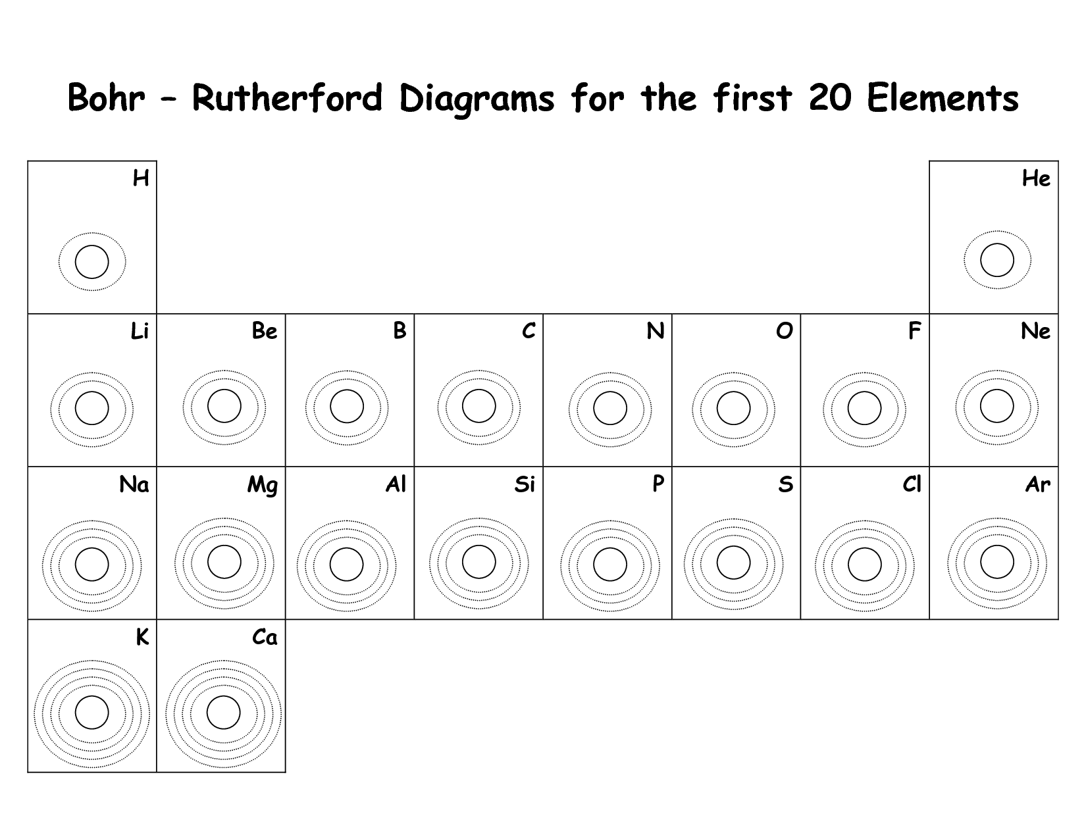
Draw the Bohr model diagram for the IONS of the first 20 elements of the periodic table

Questions:
- For the metallic elements, what is the relationship between the ion charge and the number of electrons in the outer shell?

- For the non-metals, what is the relationship between the ion charge and the number of electrons in the outer shell?

- Compared the number of vacancies, or empty spaces, in the outer shell of the non-metals with the ion charges. What is the relationship?

- How many electrons are in the outer shell of the elements Lithium (Li) and Sodium (Na) in Group 1?

- How many vacancies are in the outer shell of the elements Fluorine (F) and Chlorine (Cl) in Group 17?

- What is the pattern between the number of electrons in the outer shell of an element and its positioon along the row in the Periodic Table?

- How many shells are needed for the elements in each of the first four rows of the Periodic Table?

