Vascular Tissue Worksheet
Read pages 491 – 501 to answer the following
- What are the three primary organs in a vascular plant?

- What is meristematic tissue? Why is it important?

- What is the function of parenchymal tissue?

- What is the most important type of phloem cell? Why?

- What is the main difference between xylem and phloem?

- Why is it important to the plant that phloem moves both up and down?

- Between the xylem and phloem in the stem is a layer of cambium tissue. What is the role of this tissue?

- What is the role of the sclerenchyma tissue, found within the vascular bundle?

- Extending: Phloem cells need a lot of energy to transport sugar solution and other substances around the plant. Explain why xylem does not need energy to transport water.

Using Analogies
In an analogy, pairs of words have a similar relationship. Eg. “dark is to black as short is to small”.
Fill in the blanks using the word bank to complete the following analogies.

Meristematic tissue
Cork cambium
Parenchyma
Vascular tissue
Vessel element
Companion cells
Pericycle
Apical meristem
Vascular cambium
Sclerenchyma
Tracheid
Sieve tube elements
Epidermal Tissue

- Parenchyma is to storage as ________________________ is to support.
- ____________________ is to growth as vascular tissue is to transport.
- Tracheids are to xylem tissue as _____________________ are to phloem tissue.
- Cambium is to thickening and branching as _____________________ is to length.
- Parenchyma is to potatoes as ______________________ is to linen.
- _______________________ is to water absorption as xylem is to water transport.
Label the diagram:

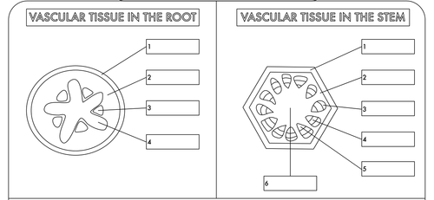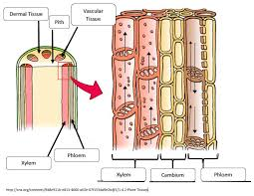
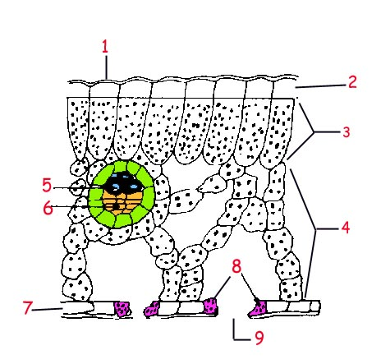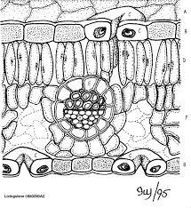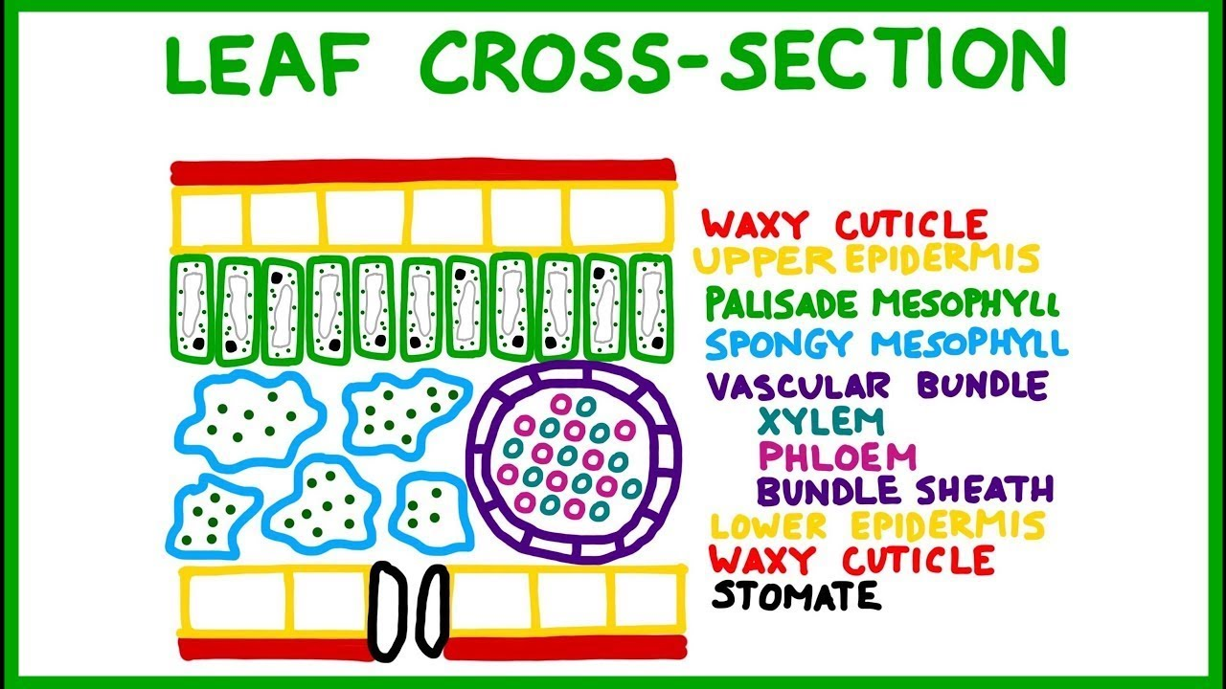
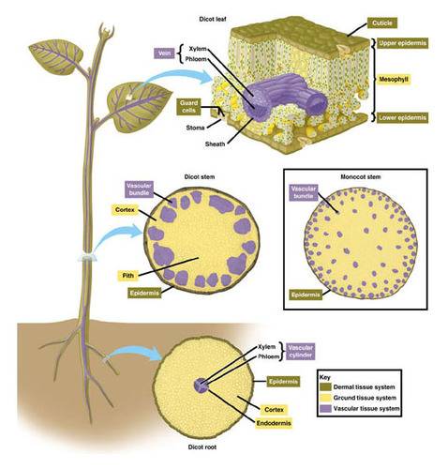
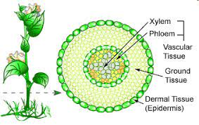

Vascular plants, also known as tracheophytes, are plants found on land that have lignified tissues for conducting water and minerals throughout the body of the plant.
- These lignified tissues are also called vascular tissue and consist of water-conducting xylem tissue and food-conducting phloem tissue.
- Vascular tissue forms a central column, also called stele, through the plant axis for the transport of different substances.
- Vascular plants are said to have a true stem, leaves, and roots due to the presence of vascular tissues.
- The root is a true root that enables the plant to anchor onto the soil and gets nutrients from it.
- The leaves are broad and have stomata that work for gas exchange and support transpiration.
- The stem of vascular plants is multilayered with vascular tissue that helps in the protection and conduction of food and water.
- The arrangement of these issues might be different in a different group of plants as it depends on the pattern of division of cells.
- The xylem is composed of non-living matter, tracheids, and vesicles, hardened by lignin that provides a stiff structure to the tissue. The phloem, on the other hand, contains living sieve elements that are not lignified.
- Vascular plants are capable of surviving on land due to their ability to transport food, water, and mineral to different parts of the plant by creating pressure through the tissues.
- Besides, they also have several modifications that facilitate their survival on land.
- Another essential characteristic of vascular plants is that the principal generation phase in these plants is the sporophytic phase where they produce diploid spores.
- Vascular plants are tall and large in size compared to the non-vascular plants because of their ability to transport necessary substances to all parts of the body via vascular tissue.
- It is believed that vascular plants are a more evolved version of non-vascular plants and thus came later in the evolutionary history.
- Vascular plants are divided into two groups; non-seed plants or lower vascular plants or cryptograms and seed plants or higher vascular plants or phanerogams.
- The lower vascular plants include plants like ferns that although are adapted to survive on land still have some characteristics of their aquatic ancestry. These plants belong to the group Pteridophyta.
- The higher vascular plants are numerous and extremely diverse and are further divided into different subgroups.
- Some examples of vascular plants include maize, mustard, rose, cycad, ferns, clubmosses, grasses, etc.

Non-vascular Plants Definition
Non-vascular plants, also known as bryophytes or lower plants, are plants mostly found in damp and moist areas and lack specialized vascular tissues.
- Both xylem and phloem are absent in these plants, and thus they are primitive plants with primitive parts.
- Non-vascular plants consist of higher structural forms of algae, mosses, liverworts, and hornworts.
- These mostly live in water and in swampy, bogs, or shady locations. These are also comparatively shorter and simpler as they are limited due to the lack of vascular tissues.
- Non-vascular plants do not have true roots, stems, or leaves and the tissues present are the least specialized forms of tissue.
- Instead of true roots, they have rhizoids that are hair-like structures that support the plant firmly to the ground. The absorption of water and mineral in the rhizoids occurs by diffusion and osmosis.
- True leaves are also absent with no specialized tissue for the protection of water loss or the process of transpiration.
- The stem is made up of simpler tissue and is weak that cannot hold the plant like in vascular plants.
- In non-vascular plants, the gametophyte generation is more dominant with haploid gametophyte. The sporophytes of these plants develop from the gametophytes and are dependent on the gametophytes for water and minerals.
- Non-vascular plants are the primitive plants that appear first during the evolutionary process.
- These plants consist of two major groups of plants; algae and bryophytes.
- Algae are green colored lower plants that are capable of photosynthesis but lack true structures.
- Bryophytes consist of plants like most mosses and liverworts which are found in shady areas and feed on dead and decaying matter.
- Non-vascular plants often act as pioneer species as they do not require much nutrients or water for their survival and can grow on barren lands.
- Using several evolved techniques, a non-vascular plant is capable of surviving in areas inhabited by vascular plants.
- Some examples of non-vascular plants include moss, algae, liverwort, and hornwort.
