Cell Division and Asexual Reproduction (pg. 57-59, 81)
1. Complete the table below to compare sexual and asexual reproduction (p81).
 | Sexual | Asexual
# of new cells formed
# of parent cells
Genetically identical? (Y/N)

2. What is cloning? Why are all of the offspring of asexual reproduction called clone?
_____________________________________________________________________

3. Identify the method of asexual reproduction in each of the following:
i. A new tree begins to grow from the root of another tree. ________________________
ii) A single celled bacteria pinches into two. ___________________________________
iii) Mushrooms release many small cells which grow into new mushrooms. __________
4) What is spore formation? ______________________________________________
______________________________________________________________________
6) Explain the difference between budding and fragmentation.
in animals and budding in trees. __________________________________________________________________
______________________________________________________________________
7) Give an example of an animal that can do both budding and fragmentation _____________________________
8) What is the difference between budding in asexual reproduction and budding in trees?

Use your notes and pages 57-59 of your text to briefly describe the different forms of Asexual Reproduction and draw an image demonstrating the method using the minion image below for each.
Binary Fission  Eg. _____________  Description: | Budding  Eg. _____________  Description:
Fragmentation  Eg.  Description: | Spore Formation  Eg.  Description:

Vocabulary

asexual reproduction
binary fission
budding
clone
cuttings
DNA
fragmentation
grafts
spore formation
vegetative reproduction

Use the terms in the vocabulary box to fill in the blanks. You can use each term more
than once. You will not need to use every term.
- A _________________________is an identical genetic copy of its parent.

2. In _________________________, only one parent is required to produce offspring.

- _________________________is a method of reproduction for some types of bacteria.

4. Some simple organisms, such as hydras and sponges, are able to reproduce
asexually by _______________________ .

5. Certain species of sea stars, corals, and mosses can reproduce asexually by _______________.

6. ____________________________occurs when special cells in the stems and roots divide repeatedly to form structures that eventually develop into a plant identical to the parent.

7. Some bacteria can reproduce asexually when their single cells split in two, forming new individuals in a process called ____________________.

8. Human-assisted cloning can be used to save the _______________________of an organism or mass produce an organism with a desired trait.
9. ________________________are cells that have the potential to become many different types of cells.

In 1952, tadpoles were first cloned. Dolly the sheep was the first mammal to be successfully cloned. It was accomplished by taking the nucleus from a body cell of an adult female sheep and fusing it with a denucleated egg cell from another adult female sheep. The resulting embryo was placed inside the womb of a third sheep.
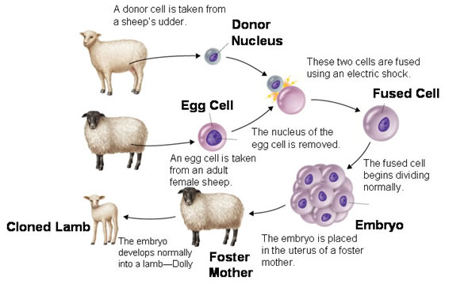

Read pages 61-62 to answer the questions about cloning.
- If we can clone large mammals like Dolly the sheep, do you think cloning humans is possible?

- Do you think scientists should clone mammals? Read the arguments in the chart on page 63 to support your response.

