Leaf Worksheet 1
Read pages 502-511 to answer the following questions
- What is the function of the epidermis and cuticle layers?

- Describe how vascular plants control gas exchange and water loss.

- Describe the structure and function of mesophyll tissue.

- Stems don’t contain a lot of mesophyll tissue. Why not?

- Why does mesophyll need to be moist? p503

- What role do cohesion and adhesion of water molecules play in the movement of water in xylem tissue? p505.

- In your own words, describe the process of Transpiration pull. p506

- What are three adaptations of desert plants? 508-509

- Why might climbing plants survive better in tropical rain forest than some nonclimbing plants? P510

- Color the diagram below then identify the following:

A ___________________________
B ___________________________
C ___________________________
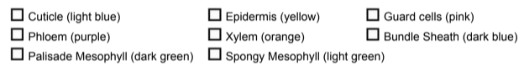
D ___________________________
E ___________________________
F ___________________________
G ___________________________
H ___________________________

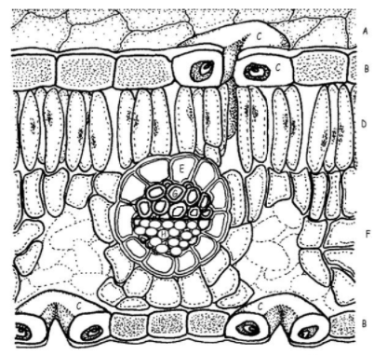

Color the diagram below then identify the following:
- Compare simple and compound leaves. How are these shapes related to solar energy collecting?

Read the following information on the leaf to label and color the diagram below.
The outer surface of the leaf has a thin waxy covering called the cuticle (A), this layer's primary function is to prevent water loss within the leaf. Directly underneath the cuticle is a layer of cells called the epidermis (B). The vascular tissue, xylem and phloem are found within the veins of the leaf. Veins are actually extensions that run from to tips of the roots all the way up to the edges of the leaves. The outer layer of the vein is made of cells called bundle sheath cells (E), and they create a circle around the xylem and the phloem. In the picture, xylem is the upper layer of cells (G) and is shaded a little lighter than the lower layer of cells - phloem (H). Recall that xylem transports water and phloem transports sugar (food).
Within the leaf, there is a layer of cells called the mesophyll. The word mesophyll is greek and means "middle" (meso) "leaf" (phyllon). Mesophyll can then be divided into two layers, the palisade layer (D) and the spongy layer (F). Palisade cells are more column-like, and lie just under the epidermis, the spongy cells are more loosely packed and lie between the palisade layer and the lower epidermis. The air spaces between the spongy cells allow for gas exchange. Mesophyll cells (both palisade and spongy) are packed with chloroplasts, and this is where photosynthesis actually occurs.
Epidermis also lines the lower area of the leaf (as does the cuticle). The leaf also has tiny holes within the epidermis called stomata. Specialized cells, called guard cells (C) surround the stomata and are shaped like two cupped hands. Changes within water pressure cause the stoma (singular of stomata) to open or close. If the guard cells are full of water, they swell up and bend away from each other which opens the stoma. During dry times, the guard cells close.

- List the main parts of the leaf and their functions.

