Sci 9 Biomagnification Activity Name:

Introduction:
Polychlorinated biphenyls (PCBs) are highly toxic industrial compounds used around the world since the 1930s and were finally banned in 1970s and 1980s in several countries. But they are still around because they decompose very slowly.
When these toxins get ingested by an organism, they do not get broken down or eliminate and accumulate in the fatty tissues of living animals. This is called bioaccumulation.

PCBs absorbed by smaller animals get progressively more concentrated the higher up the food chain as larger organism eat many smaller organisms. This is called biomagnification.

Orcas are an apex predator—they are at the top of the food web. They eat fish, seals, sea lions, sharks, or whales, and have no natural predators. They have been shown to have the highest levels of PCBs in their systems.
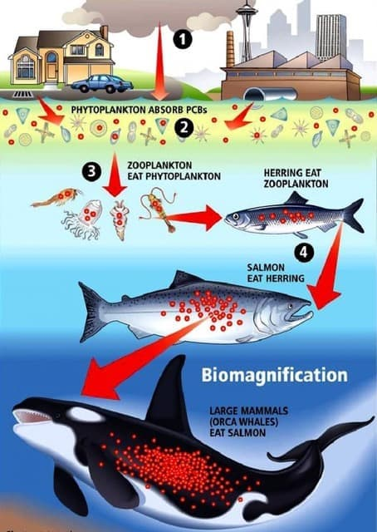
Studies have shown that animals with PCB levels as low as 50 milligrams per kilo of tissue may show signs of infertility and severe impacts on the immune system. Researchers have measured values as high as 1300 milligrams per kilo in the fatty tissue (blubber) of killer whales. Research indicates the current concentrations of PCBs could lead to the disappearance of half of the world's populations of killer whales from the most heavily contaminated areas within a period of just 30 to 50 years. Moreover, PCBs are passed down to orca offspring through the mother's fat-rich milk.

Materials:
- Name tags: Krill (x15), Herring (x9), Salmon (x4), Orca (1)
- Red and White beans as “phytoplankton” and zooplankton
- Cups (x30)

What to do:
- Round 1: Krill, simulate feeding on plankton (beans) by gathering the ‘food’ distributed in the classroom. Put your collected ‘food’ in the container provided. You have 20 seconds to ‘feed’.
- Round 2: Krill begin to feed again for 20 sec. Then herring have 20 seconds to feed on krill by tapping krill on the shoulder and playing rock, scissors, paper. If herring wins, they pour the contents of the krill’s cup into their own. If krill wins, herring moves on and krill keeps feeding. “Eaten” krill continue to feed, giving up the contents of their cup each time they are tapped.

- Round 3: Krill feed again for 20 sec. Then herring feed on krill as before for another 20 sec, then salmon begin feeding on herring only by tapping them on the shoulder and playing rock, scissors, paper to decide who gets the contents of the cup. Eaten krill and herring continue to feed, giving up contents when necessary.

- Round 4: All feed. Orca feeds on salmon only. Others continue to feed as before.

- Survivors pool their beans and count total white and coloured beans separately. Report results on to the board.

- 90% of the energy gained from the food is used up for metabolic processes. Only 10% remains in tissues and will get transferred up to the next trophic level when eaten. Calculate 90% of your white beans. Record in chart.

- Toxins are not used in metabolism and do not get broken down or eliminated, so all of it ends up in the tissues of the organism. The dark beans represent a persistent pollutant or toxin (like mercury or DDT).

- Calculate “Percent Toxicity” of your tissues by dividing the number of dark beans by the total beans retained. (Dark beans + 10% of your white beans). Then multiply by 100.

- Determine the “Health” of the group in each round: If an organism has between 0-29 % black beans, it is still healthy, 30-49 % Sick, > 50% black beans it should be dead.

Class Data Table
 | Total White beans | Total coloured beans | 10% of white beans remaining | % Toxicity:  # coloured x 100  Total beans remaining | Health:  0-29 %, still healthy,  30-49 % Sick,  > 50% dead or dying
Krill
Herring
Salmon
Orca

Questions
- What is the difference between bioaccumulation and biomagnification?

- Some orcas eat mostly sealions whereas some eat mostly salmon. Which orca population would you expect to have the highest PCB concentrations? Why?

- Besides PCBs, another common toxin that builds up over time is mercury. Using the scenario from the activity, answer the following question:
If you really liked fish, would it be better to eat several small fish or one big fish? Justify your answer

Critical Thinking
- EVALUATE: The chemical DDT was a popular crop pesticide that was banned in many countries due to its persistence in the environment and detrimental effects on wildlife and humans. DDT is effective against mosquitoes that carry malaria. Over one million people die from malaria each year. Do you think the use of DDT should be reinstated in countries where malaria is prevalent? If not, what do you suggest? Justify your answer.

Not done this year
- If one does enjoy fish, why is it recommended that you eat smaller fish like salmon, sardines, and smelt, but less large fish like swordfish, pickerel or tuna? (Hint: look at what each of those fish eat)

- What do you think would happen to an orca population whose PCB levels remained at 50 mg/kg of tissue? (Hint: read the intro again).
  - Who would have a greater concentration of mercury in their body – A person eating fish daily? A person who eats fish weekly? A person who eats fish only every now and then? Why?

Go here for instructions
https://stao.ca/activity-to-demonstrate-the-process-of-bioaccumulation-in-food-chains/
Discuss how the smaller concentrations in lower organisms are sufficient enough to cause death or damage to the organism. As such, in the simulation, any herring that have not been eaten and who hold at least one coloured shrimp are dead. In the case of the salmon, any individuals who have more than half of their shrimp printed on coloured paper are also dead. Since higher level organisms are capable of storing higher concentrations of persistent pollutants with less dramatic effect, the Grizzly bears who have coloured pieces are no longer able to reproduce.
In a senior classroom, the opportunity arises to discuss the idea of chemical trespass, as well as the lack of labeling on products that contain potentially harmful chemicals, and the impacts of the use of herbicides and pesticides. (I like to follow up by showing the documentary, “The Slow Poisoning of India”. It may be found for free at:
http://watchdocumentary.org/watch/the-slow-poisoning-of-india-video_afafea80e.html .
Variations include taking your class outside to play where there is appropriate space for students to run and chase each other in a game of tag, or using individually wrapped candies as the lowest trophic level, in place of the paper shrimp. The latter requires a modification to the discussion, which would focus on the increased concentration of the pollutant (candy wrappers) in each trophic level. Students would then be collecting the wrappers from individuals they have eaten. The candy modification requires having extra candy on hand for those students who are not herring. You may also wish to change the food chain such that it is one that is relevant to your area.

